**Input:**

F(x): x3 – 2*sin(x)

a = 0.5

b = 2

EPS = 0.00001

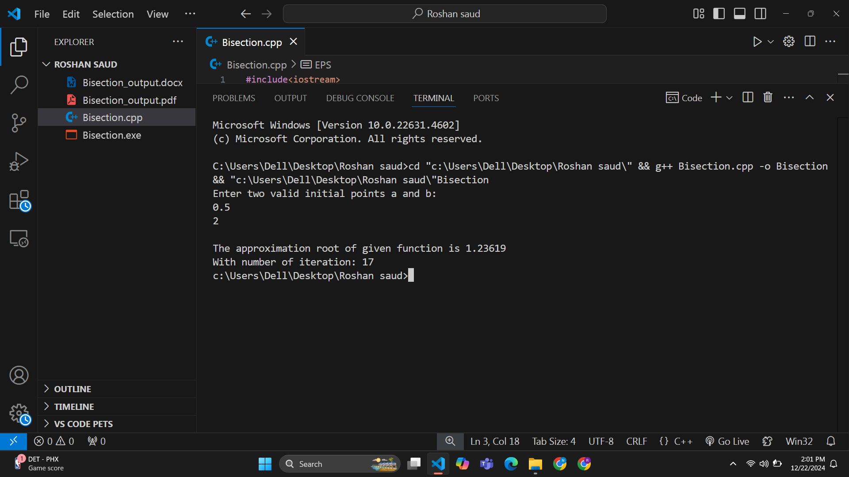**Output:**

**Input:**

F(x): x*ex – 1

a = 0

b = 1

EPS: 0.000001

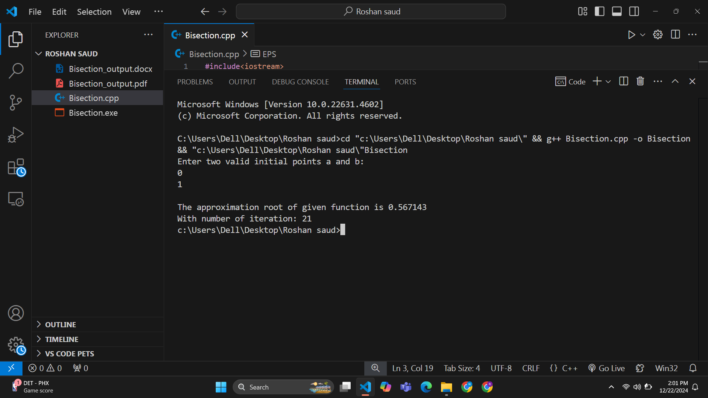**Output:**